Exercise 7 - Table Creation (DDL)
Create new tables by using the CREATE TABLE statement. Confirm that the new table
was added to the database. You also learn to set the status of a table as READ ONLY and
then revert to READ/WRITE.

Note: For all the DDL and DML statements, click the Run Script icon (or press [F5]) to
execute the query in SQL Developer. This way you get to see the feedback messages on
the Script Output tabbed page. For SELECT queries, continue to click the Execute
Statement icon or press [F9] to get the formatted output on the Results tabbed page.
Using DDL Statements to Create and Manage Tables
1) Create the DEPT table, based on the following table instance chart. Save the statement
in a script called lab_10_01.sql, and then execute the statement in the script to
create the table. Confirm that the table is created.
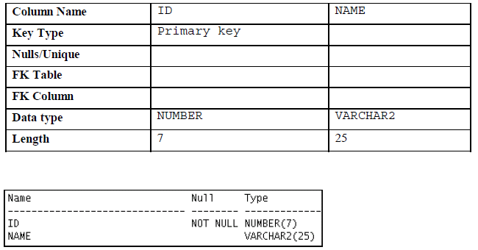
2) Populate the DEPT table with data from the DEPARTMENTS table. Include only
columns that you need.

3) Create the EMP table based on the following table instance chart. Save the statement
in a script called lab_10_03.sql, and then execute the statement in the script to
create the table. Confirm that the table is created.

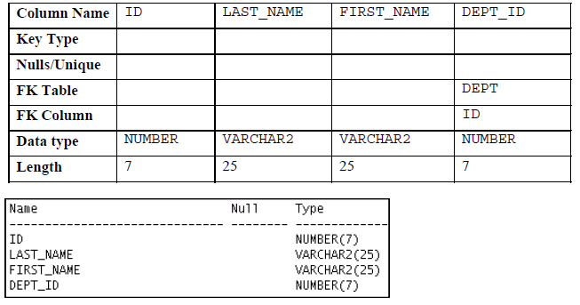

4) Create the EMPLOYEES2 table based on the structure of the EMPLOYEES table. Include only the EMPLOYEE_ID, FIRST_NAME, LAST_NAME, SALARY, and DEPARTMENT_ID columns. Name the columns in your new table ID, FIRST_NAME, LAST_NAME, SALARY, and DEPT_ID, respectively.

5) Alter the EMPLOYEES2 table status to read-only.

6) Try to insert the following row in the EMPLOYEES2 table:
You get the following error message:

7) Revert the EMPLOYEES2 table to the read/write status. Now, try to insert the same
row again. You should get the following messages:

8) Drop the EMPLOYEES2 table.
ID FIRST_NAME LAST_NAME SALARY DEPT_ID
34 Grant Marcie 5678 10
Oracle Database 11g: SQL Fundamentals I A - 76
______________________________________________________________________________________________

Practice 1-1: Creating Other Schema Objects
Part 1
1) The staff in the HR department wants to hide some of the data in the EMPLOYEES
table. Create a view called EMPLOYEES_VU based on the employee numbers,
employee last names, and department numbers from the EMPLOYEES table. The
heading for the employee name should be EMPLOYEE.

2) Confirm that the view works. Display the contents of the EMPLOYEES_VU view.

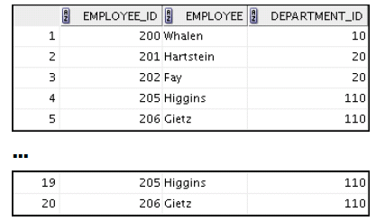

3) Using your EMPLOYEES_VU view, write a query for the HR department to display all
employee names and department numbers.

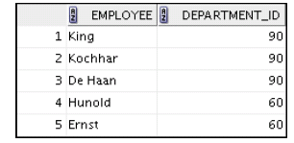
4) Department 50 needs access to its employee data. Create a view named DEPT50 that
contains the employee numbers, employee last names, and department numbers for
all employees in department 50. You have been asked to label the view columns
EMPNO, EMPLOYEE, and DEPTNO. For security purposes, do not allow an employee to
be reassigned to another department through the view.

5) Display the structure and contents of the DEPT50 view.

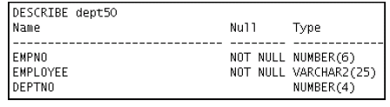

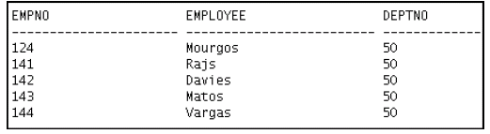

6) Test your view. Attempt to reassign Matos to department 80.

Part 2
7) You need a sequence that can be used with the PRIMARY KEY column of the DEPT
table. The sequence should start at 200 and have a maximum value of 1,000. Have
your sequence increment by 10. Name the sequence DEPT_ID_SEQ.

8) To test your sequence, write a script to insert two rows in the DEPT table. Name your
script lab_11_08.sql. Be sure to use the sequence that you created for the ID
column. Add two departments: Education and Administration. Confirm your
additions. Run the commands in your script.

9) Create a nonunique index on the NAME column in the DEPT table.

10) Create a synonym for your EMPLOYEES table. Call it EMP.

